**Day 3 – E-Mail Service**

1. Research the following internet protocols related to e-mail services.
   1. SMTP Protocol
   2. POP3 Protocol
   3. IMAP Protocol
   4. Web Mail
2. Use the following resource as a starting point:  
   <https://askleo.com/what_is_pop_or_pop3_or_a_pop_account_and_what_about_smtp/>
3. Complete the following Venn Diagram to summarize your research.

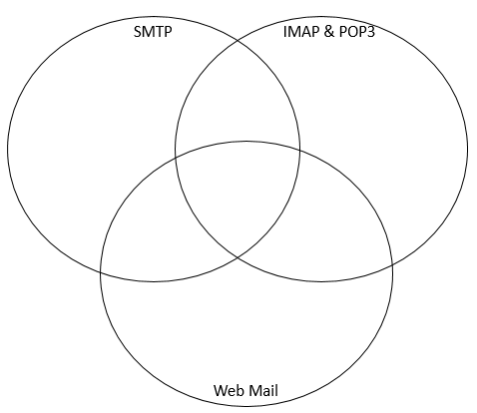

**SMTP** is the protocol for sending email whether it is from the client or in between servers for propagating the email towards the intended destination

**SMTP** is the protocol for sending email whether it is from the client or in between servers for propagating the email towards the intended destination.

**IMAP** is a protocol that deals with managing **and** retrieving email messages from the server.

**POP3** is a client/server protocol in which e-mail is received and held for you by your Internet server. Periodically, you (or your client e-mail receiver) check your mail-box on the server and download any mail, probably using **POP3**.

**Webmail:** an email system in which a user can access their emails via a browser on any computer or device that is connected to the Internet.

Similarities: All the functions work together via email. All each play a part to make the email function work and move smoothly.